Databases and their uses

Introduction to databases

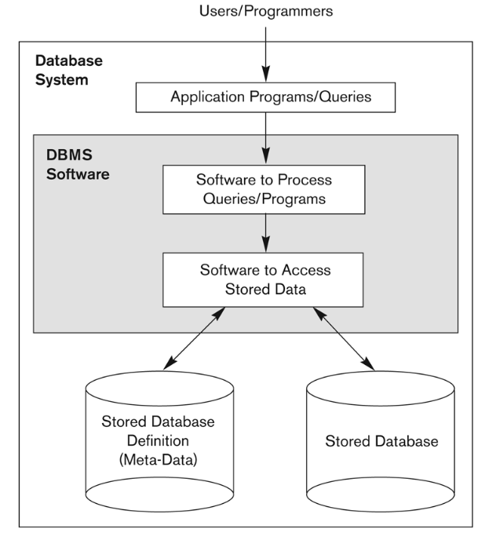
Database uses
Traditional applications:
- Numeric and Textual databases
More recent applications:
- Multimedia databases
- Geographic Information Systems (GIS)
- Data warehouses
- Real-time and Active databases
- etc.

Basic definitions
- Database:
A collection of related data.
- Data:
Known facts that can be recorded and have an implicit meaning.
- Mini-world:
Some part of the real world about which data is stored in a database. For example, student grades and transcripts at a university.
- Database Management System (DBMS):
A software package/system to facilitate the creation and maintenance of a computerised database.
- Database system:
The DBMS software together with the data itself. Sometimes applications are also included.

Typical DBMS functionality
- Define a particular database in terms of its data types, structures and constraints
- Construct or load the initial database contents on a secondary storage medium
- Manipulating the database:
  - Retrieval: Querying, generating reports
  - Modification: Insertions, deletions and updates to its content
  - Accessing the database through web applications
- Processing and sharing by a set of concurrent users and application programs – yet, keeping all data valid and consistent.
- Other features:
  - Protection or security measures to prevent unauthorised access
  - “Active” processing to take internal actions on data
  - Presentation and visualisation of data
  - Maintaining the database and associated programs over the lifetime of the database application
    - Called database, software and system maintenance

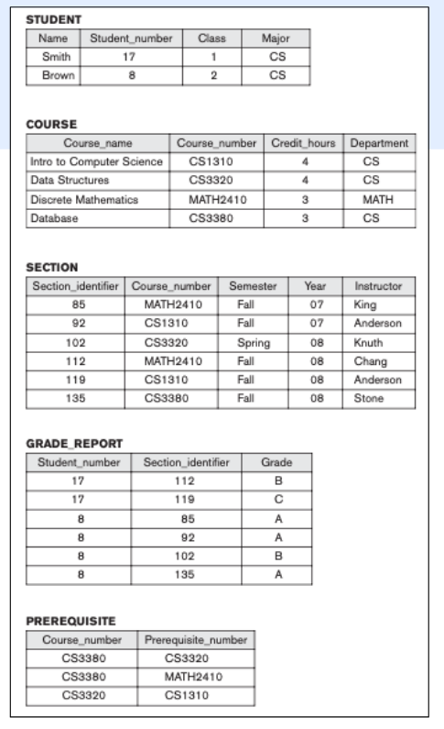
Database with a conceptual data model
- Mini-world: Part of a UNIVERSITY environment.
- Entities include: STUDENTs, COURSEs, SECTIONs (of COURSEs), (academic) DEPARTMENTs, INSTRUCTORs
- Mini-world relationships:
  - SECTIONS are of specific COURSEs
  - STUDENTs take SECTIONs
  - COURSEs have prerequisite COURSEs
  - COURSEs are offered by DEPARTMENTs
  - STUDENTs register in DEPARTMENTs
UNIVERSITY database that stores student and course data.

Characteristics of a database approach
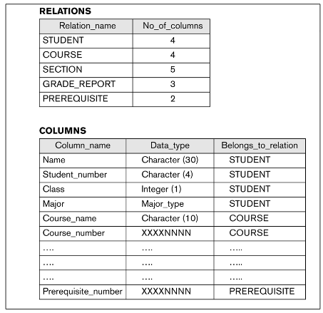
- Self-describing nature of a database system:
  - A DBMS catalog stores the description of a particular database (e.g. data structures, types and constraints)
  - The description is called meta-data
  - This allows the DBMS software work with different database applications.
- Insulation between programs and data:
  - Called program-data independence
  - Allows changing data structures and storage organisation without having to change the DBMS access programs.
- Data abstraction:
  - A data model is used to hide storage details and present the users with a conceptual view of the database.
  - Programs refer to the data model constructs rather than data storage details.
- Support of multiple views of the data:
  - Each user may see a different view of the database, which describes only the data of interest to that user.
- Sharing of data and multi-user transaction processing
  - Allowing a set of concurrent users to retrieve from and to update the database.
  - Concurrency control within the DBMS guarantees that each transaction is correctly executed or aborted
  - Recovery subsystem ensures each completed transaction has its effect permanently recorded in the database
  - Online Transaction Processing (OLTP) is a major part of database applications. This allows hundreds of concurrent transactions to execute per second.

Advantages of databases
- Controlling redundancy in data storage and indevelopment and maintenance efforts
- Providing multiple interfaces to different classes of users, facilitate sharing data across uers
- Restricting unauthorised access to data
- Providing Storage Structures (e.g. indexes) for efficient query processing
- Providing backup and recovery services
- Representing complex relationships among data
- Enforcing integrity constraints on the database
- Drawing inferences and actions from the stored data

Additional implications
Flexibility to change data structures
- Database structure may evolve as new requirements are defined
Availability of current information
- Extremely important for online transaction systems
Economies of scale
- Wasteful overlap of resources and personnel can be avoided by consolidating data and applications across departments

When not to use a DBMS
Main inhibitors of using a DBMS:
- High investment required for additional hardware, providing generality, security, concurrency control, recovery and integrity functions.
When a DBMS may be unnecessary:
- If the database and applications are simple, well defined, and not expected to change or if access to data by multiple users is not required
When no DBMS may suffice:
- If the database system is not able to handle the complexity of data because of modeling limitations.
- If there are stringent real-time requirements that may not be met because of DBMS overhead
- If the database users need special operations not supported by the DBMS

Data models and principles of database architecture

Data models
These are a set of concepts to describe the structure of a database, the data types, relationships and certain constraints that apply to the data. May include basic operations for retrievals or updates.
Data model structure and constraints:
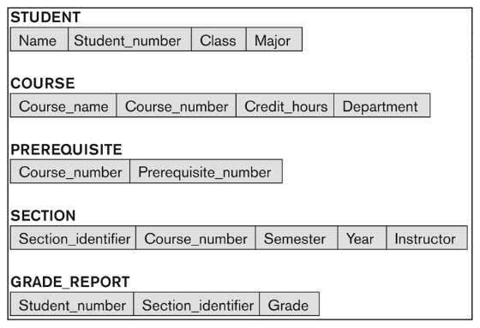
- Constructs are used to define the database structure
- Constructs typically include elements (and their data types) as well as groups of elements (e.g. entity, record, table), and relationships among such groups.
- Constraints specify some restrictions on valid data; these constraints must be enforced at all times.
Data model operations:
- These operations are used for specifying database retreivals and updates by referring to the constructs of the data model.
- Operations may include
  - basic model oeprations (e.g. generic insert, delete, update)
  - user-defined operations (e.g. compute_student_gpa, update_inventory)

Categories of data models
Conceptual (high-level, semantic) data models:
- Provide concepts that are close to the way many users perceive data.
- Also called entity-based or object-based data models.
Physical (low-level, internal) data models:
- Provide concepts that describe details of how data is stored in the computer. These are usually specified in an ad-hoc manner through DBMS design and administration manuals.
Implementation (representational) data models:
- Provide concepts that fall between the above two, used by many commercial DBMS implementations (e.g. relational data models used in many commercial systems)

Types of data models
- Relational model
- Network model
- Hierarchical model
- Object-oriented data models
- Object-relational models

Network model schema
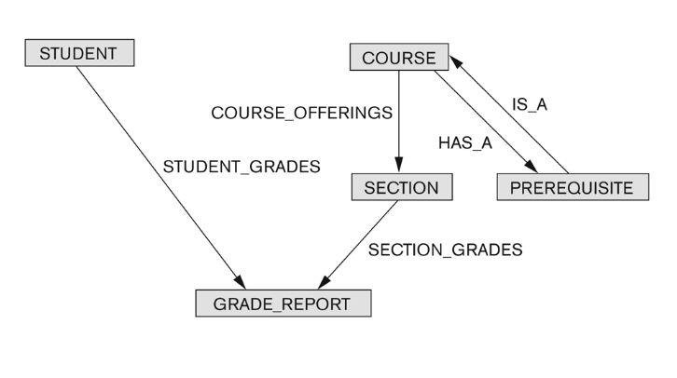
Advantages:
- Network model is able to model complex relationships
- Can handle most situations for modeling using record types and relationship types
- Language is navigational; uses constructs like FIND, FIND member, FIND NEXT within set, GET, etc.
  - Programmers can do optimal navigation through the database
Disadvantages:
- Navigational and procedural nature of processing
- Database contains a complex array of pointers that thread through a set of records
- Little scope for automated “query optimisation”

Relational data model schema
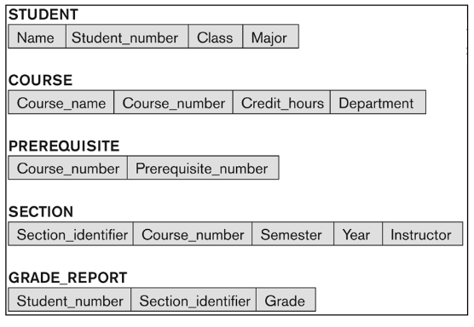
- Proposed in 1970 by E.F. Codd (IBM), first commercial system in 1981-82
- Appears in several commercial products (e.g. DB2, ORACLE, MS SQL Server, SYBASE, INFORMIX).
- Several free open source implementations e.g. MySQL, PostgreSQL
- Currently most dominant for developing database applications

Database schema
- The description of a database
- Includes descriptions of the database structure, data types, and the constraints of the database
Schema diagram:
- An illustrative display of (most aspects of) a database schema.
Schema construct:
- A component of the schema or an object within the schema, e.g. STUDENT, COURSE.

Database state
The actual data stored in a database at a particular moment in time. This includes the collection of all the data in the database.
- Also called database instance (or occurrence or snapshot).
- The term instance is also applied to individual database components, e.g. record instance, table instance, entity instance
Refers to content of a database at a moment in time
- Initial database state: refers to the database when it is initially loaded into the system
- Valid state: a state that satisfies the structure and constraints of the database.

Schema vs state
Distinction:
- The schema changes infrequently
- The state changes every time the database is updated.
Schema is also called intension.
State is also called extension.

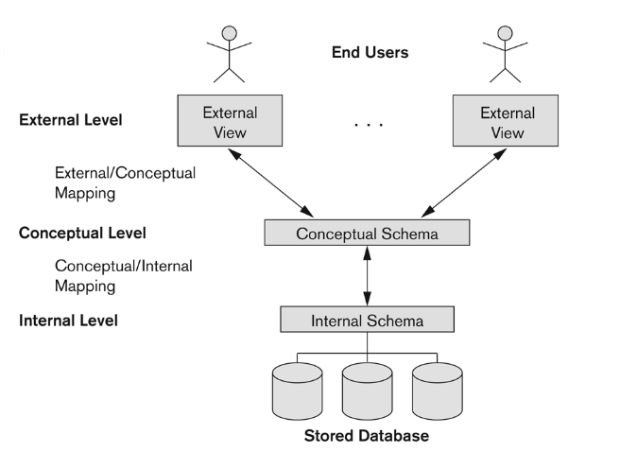
Three-schema architecture
This was proposed to support DBMS characteristics of:
- Program-data independence
- Support of multiple views of the data.
Not explicitly used in commercial DBMS products, but has been useful in explaining database system organisation.
- Defines DBMS schemas at three levels:
- Internal schema at the internal level to describe physical storage structures and access paths (e.g. indexes)
  - Typically uses a physical data model
- Conceptual schema at the conceptual level to describe the structure and constraints for the whole database for a community of users
  - Uses a conceptual or an implementaiton data model
- External schemas at the external level to describe the various user views.
  - Usually uses the same data model as the conceptual schema.
Mappings among schema levels are needed to transform requests and data.
- Programs refer to an external schema and are mapped by the DBMS to the internal schema for execution.
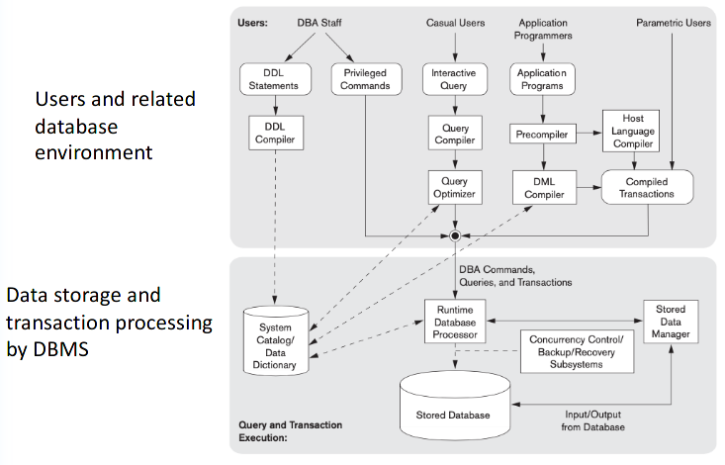
- Data extracted from the internal DBMs level is reformatted to match the user’s external view (e.g. formatting the results of an SQL query for display in a web page).

Database components

DBMS languages
Data definition language (DDL)
- Specify conceptual and internal schemas
Data Manipulation Language (DML)
- Used to query and manipulate the database
  - High-Level or Non-procedural Languages: These include the relational language SQL
    - May be used in a standalone way or may be embedded in a programming language
  - Low Level or Procedural Languages:
    - These must be embedded in a general-purpose programming language

DDL
Used by the DBA and database designers to specify the conceptual schema of a database.
In many DBMSs, the DDL is also used to define internal and external schemas (views).
In some DBMSs, separate storage definition language (SDL) and view definition language (VDL) are used to define internal and external schemas.
- SDL is typicall y realised via DBMS commands provided to the DBA and database designers

DML
Used to specify database retrievals and updates.
DML commands (data sublanguage) can be embedded in a general-purpose programming language (host language) such as C, C++, or Java.
- A library of functions can also be provided to access the DBMS from a programming language.
Alternatively, stand-alone DML commands can be applied directly (called a query language)

Centralised and client-server dbms architectures
Centralised DBMS:
- Combiens everything into a single system, including DBMS software, hardware, application programs, and user interface processing software
- User can still connect through a remote terminal – however, all processing is done at centralised site.
Three tier client-server architecture:
- Common for web applications
- Intermediate layer called Application Server or Web Server:
  - Stores the web connectivity software and the business logic part of the application used to access the corresponding data from the database server
  - Acts like a conduit for sending partially processed data between the database server and the client
- Three tier architecture can enhance security:
  - Database server only accessible via middle tier
  - Clients cannot directly access server

Classification of dbms
- Based on the data model used
  - Traditional: Relational, Network, Hierarchical
  - Emerging: Object-oriented, Object-relational
- Other classifications
  - Single-user (typically used with personal computers) vs. Multi-user (most DBMSs)
  - Centralised (uses a single computer with one database) vs. Distributed (uses multiple computers, multiple databases)

Distributed dbms variations
- Homogenous DDBMS
  - Same DBMS in all sites
- Heterogenous DDBMS
  - Several autonomous DBMS software at multiple sites, connected through network
- Federated or multidatabase systems
  - DBMSs loosely coupled, have some autonomy

